**WEB DESIGN**

*Mid Term*

|  |  |
| --- | --- |
| **Course** | Web Design |
| **Exam Type** | **Mid Term** |
| **Duration** | 2 hours |
| **Generation** | GEN-10 |
| **Date** | NOV 20th 2024 |
| **Exam Rules** | * All documents allowed * The following actions are forbidden and will conduct to a 0 score:   + Talking or exchanging information with another student   + Using Internet or any Network |

Evaluation

|  |  |
| --- | --- |
| **Exercise 1** | 20 points |
| **Exercise 2** | 30 points |
| **Exercise 3** | 50 points |

To start

* Read this **document** AND the start **code** (ZIP) from MS TEAM

To submit

* Submit this **document** AND your **code** (ZIP) on MS TEAM

**EXERCISE 1 (20 pts)** *CRITICAL THINKING*

**Q1 – 6 pts**

You need to apply a style to 5 elements on a page.

*Would you* ***use a class, an ID, or a type selector?*** *Justify your choice and explain the potential risks of each method.*

I would use a class selector to choose the 5 element with the same class because it’s easy to use and manage allowing for easy access and change. The potential risk of ID is it must be unique and cannot be used multiple times. Type selector would affect all element with the same type making it hard to have precise control over the elements u want to select.

**Q2 – 3 pts**

You are tasked to design a button with an exact width of 100px, including padding and borders.

*Which* ***box-sizing mode*** *should you use,* ***and why****?*

I would use border box because it’s sometimes easier to include padding and border when specifying the elments dimension!

**Q3 – 3 pts**

You are creating a photo gallery.

*Would you use* ***Flexbox or Grid for the layout****? Explain your decision, considering alignment, responsiveness, and maintenance.*

I would use grid for the layout because it provides a 2D dimension space. It can be aligned easily with rows and columns, and provides responsiveness with grow and is easy to maintain and change any pictures whenever needed.

**Q4 – 3 pts**

You need to add space between a button and the text above it.

*Should you use margin or padding on the button? Justify your choice.*

I would use padding because border is the boundary around the elements so if the text is above the button that means its around the element (button) and margin is space outside the element making it not a viable choice.

**Q4 – 5 pts**

Here is a website folder structure.

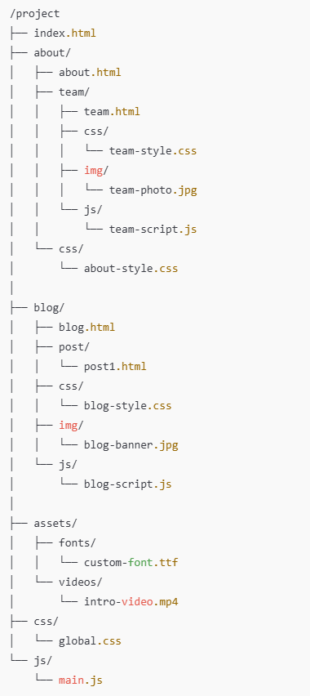

Fill up the table with the **hyperlink**, so that we **can create an anchor link** from the **source folder** to the **destination file**.

|  |  |  |  |
| --- | --- | --- | --- |
| ***PATH TYPE*** | ***SOURCE FOLDER*** | ***DESTINATION FILE*** | ***HYPERLINK LINK*** |
| ABSOLUTE |  | team-style.css | href= “team-style.css” |
| RELATIVE | project/about/team | blog.html | Href= “.../blog/blog.html” |
| RELATIVE | project/ blog/css / | team-style.css | Href= “../about/team/css/team-style.css” |
| RELATIVE | project/ blog/js / | Global.css | Href= “.../css/global.css” |
| ABSOLUTE |  | intro-video.mp4 | href= “intro-video.mp4” |

**EXERCISE 2 (30 pts)**

Design the bellow mock up using a **GRID layout**.

**PART 1** *– Main components – 25 pts*

Design the bellow mock up.

* Your need to change both CSS and HTML
* Use the color as the bellow mockup

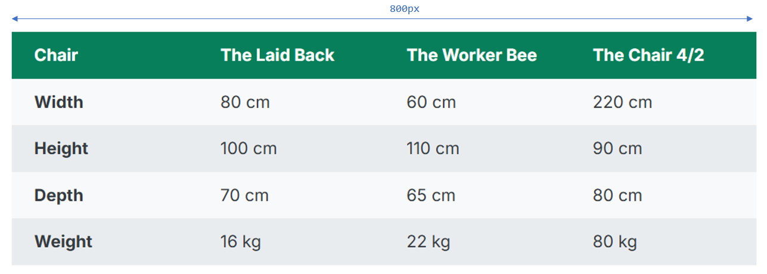

* Each cell should have the same paddings:

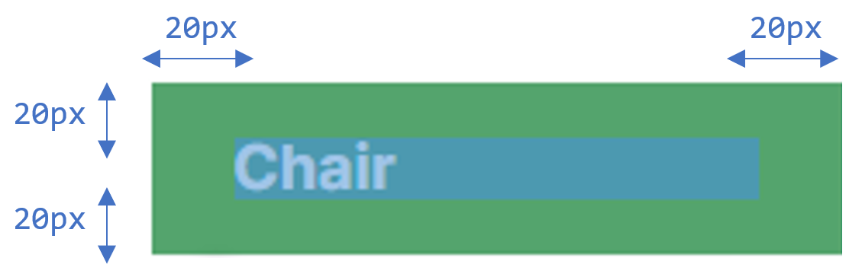

**EXERCISE 3 (50 pts)**

**PART 1** *– Main components – 20 pts*

Design the below mock up using a **GRID layout**. *(No grid layout = no points!)*

* The HTML is provided and **cannot change**.
* *Remaining* means the related row or column **shall stretch** on the available space.

Colors:

* Menu #343a40
* Left Section #7048e8
* Nav #e9ecef

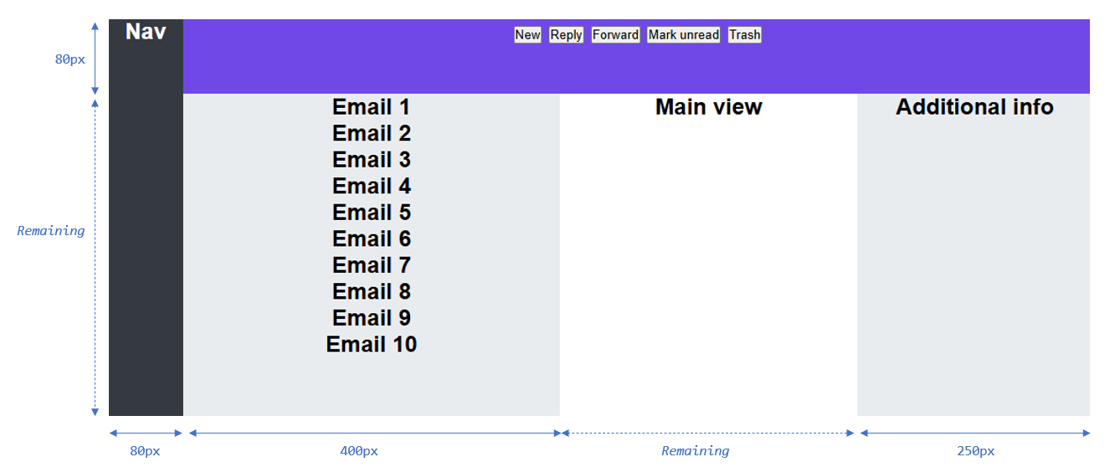

**PART 2** *– Inner elements – 30 pts*

Continue the work by designing the **menu buttons** and **email items**

* Use the types of layouts you want
* Note: the **email section has a scrollbar**: are you able to display it?

Colors:

* Menu button: # 5F3DC4
* Last menu button # d6336c
* Email # adb5bd

